[**DIGITAL SIGNAL & IMAGE PROCESSING LAB**](https://github.com/Amey-Thakur/DIGITAL-SIGNAL-AND-IMAGE-PROCESSING-AND-DIGITAL-SIGNAL-AND-IMAGE-PROCESSING-LAB)

[**EXPERIMENT -**](https://github.com/Amey-Thakur/DIGITAL-SIGNAL-AND-IMAGE-PROCESSING-LAB) **7**

**PART B**

(PART B: TO BE COMPLETED BY STUDENTS)

***(Students must submit the soft copy as per the following segments within two hours of the practical. The soft copy must be uploaded on the Blackboard or emailed to the concerned lab in charge faculties at the end of the practical in case there is no Blackboard access available)***

| **Roll No. 50** | **Name: AMEY THAKUR** |
| --- | --- |
| **Class: COMPS-BE-B-50** | **Batch: B3** |
| **Date of Experiment: 08/09/2021** | **Date of Submission: 08/09/2021** |
| **Grade :** |  |

**A.1 Aim:**

Write a program to implement Contrast Stretching, Dynamic range compression and Bit plane slicing.

**B.1 Software Code written by a student:**

***(Paste your code completed during the 2 hours of practice in the lab here)***

Contrast Stretching:

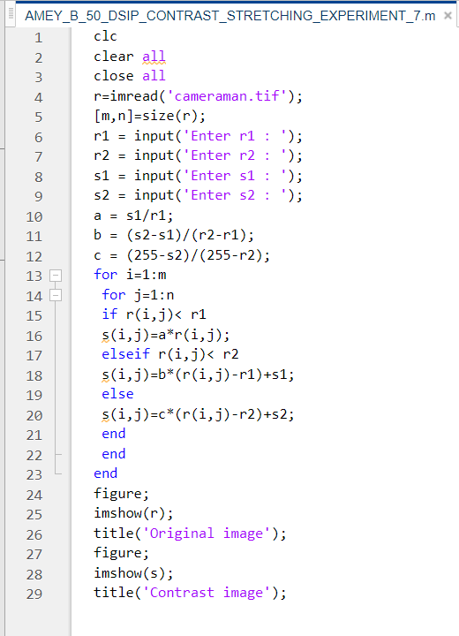

Bit Plane Slicing:

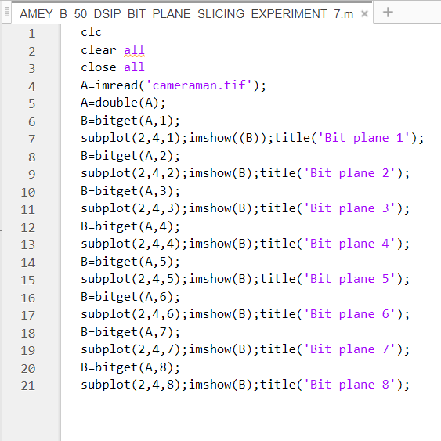

**B.2 Input and Output:**

Contrast Stretching:

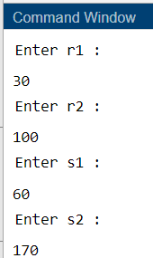

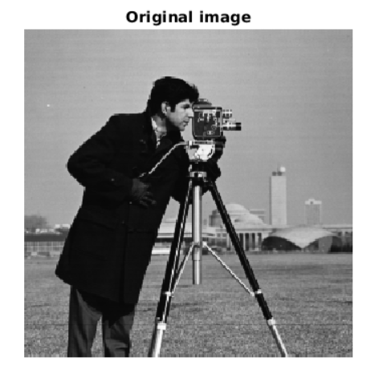

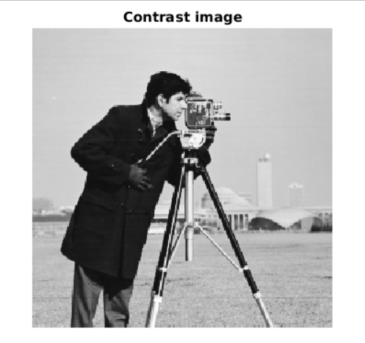

Bit Plane Slicing:

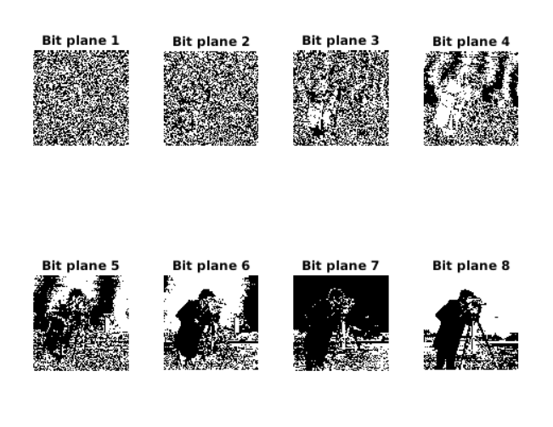

**B.3 Observations and learning:**

***(Students are expected to comment on the output obtained with clear observations and learning for each task/ subpart assigned)***

* Contrast stretching (also called Normalization) attempts to improve an image by stretching the range of intensity values it contains to make full use of possible values. - The purpose of dynamic range compression is to map the natural dynamic range of a signal to a smaller range.
* Bit plane slicing is a method of representing an image with one or more bits of the byte used for each pixel.

**B.4 Conclusion:**

***(Students must write the conclusion as per the attainment of individual outcome listed above and learning/observation noted in section B.3)***

Techniques for spatial domain image enhancement were implemented in this experiment.

**B.5 Question of Curiosity:**

***(To be answered by student based on the practical performed and learning/observations)***

1. What is Contrast Stretching?

Ans:

Contrast stretching (also called Normalization) attempts to improve an image by stretching the range of intensity values it contains to make full use of possible values. Unlike histogram equalization, contrast stretching is restricted to a linear mapping of input to output values. The result is less dramatic but tends to avoid the sometimes artificial appearance of equalized images.

1. What is compression dynamic range?

Ans:

* Sometimes the dynamic range of a processed image far exceeds the capability of the display device, in which case only the brightest parts of the images are visible on the display screen.
* An effective way to compress the dynamic range of pixel values is to perform the following intensity transformation function:

s = c log(1+|r|)

where c is a scaling constant, and the logarithm function performs the desired compression.